

**OLLSCOIL NA hÉIREANN MÁ NUAD**

**THE NATIONAL UNIVERSITY OF IRELAND MAYNOOTH**

## AUTUMN 2019 EXAMINATION

# CS320

**Computer Networks**

Dr. M. Huggard, Dr. J. Timoney, Dr. B. Hennelly

Time allowed: 2 hours

You must answer Question 1 and any three other questions.

Your mark will be based on Question 1 and your best three answers from the remaining questions

**All questions** carry equal marks

### Question1. Short Questions [20 marks]

Answer each of the following questions *briefly, i.e., in at most a few sentences (no essays please).* All questions are worth 2 marks.

1. How long does it take a packet of length 1,000 bytes to propagate over a link of distance 2,500 km, propagation speed 2.5x108 m/s, and transmission rate 2 Mbps? *Answer: Propagation delay = distance/speed = 0.01s and transmission delay = length/transmission rate = 1000*8/2000000 = 0.004. Total delay = 0.014*
2. What does it mean for a protocol to be stateful? What does it mean for a protocol to be stateless? Give an example one stateful protocol and one stateless protocol. How does HTTP maintain state? *Answer: A protocol is stateful if it maintains information about an on-going connection with the other side(s) over the course of a number of message exchanges. If no such information is maintained, and each new arriving message is handled completely separately from previous messages, the protocol is stateless. HTTP is stateless, FTP is stateful. HTTP can maintain state using a cookie, which is stored on both the server and client side and is communicated within the HTTP header.*
3. What does it mean for HTTP1.1 to be “persistent”? What is the value of HTTP1.1 being persistent, as opposed to being non-persistent, as in HTTP 1.0? *Answer: HTTP1.1 keeps a single TCP connection open while transferring multiple objects over the connection. The advantage of re-usuing the single connection is that one does not have to set up multiple connections serially, with the ensuing startup delays due to the TCP triple handshake*
4. Describe how Web caching can reduce the delay in receiving a requested object. Will Web caching reduce the delay for all objects requested by a user or for only some of the objects? Why? *Answer: Web caching can bring the desired content “closer” to the user, possibly to the same LAN to which the user’s host is connected. Web caching can reduce the delay for all objects, even objects that are not cached, since caching reduces the traffic on links. The access link from the LANs first (gateway) router will always have a significantly lower capacity than the LAN itself. Reducing traffic on this bottleneck is crucial for local speed up but it also reduces general traffic on the internet as a whole.*
5. Briefly explain the difference between GBN and SR protocols. Which one best describes TCP? *Answers: Both protocols make use of a window of sent packets into the channel that can be unacked. With GBN the receiver will only send ACKs for the last in order correctly recived packet, while SR will send an ACK for all correctly received packets – if one packet has not been received in order the later packets are buffered such that SR will only pass up in order packets to the upper layer. TCP has characteristics of both.*
6. Two services that TCP offers are flow control and congestion control. Can you briefly explain the difference between these two services? *Answer: Flow control is a service to the receiving application; the receiver advertises to the sender the available buffer space it has; the sender never sends out more unacked packets than that. Congestion control is not so much a service provided to the invoking application as it is a service for the Internet as a whole; it prevents any one TCP connection from swamping the links and routers between communicating hosts with an excessive amount of traffic. If the sender detects a lost packet it halves the number of unacked packets it can send.*
7. Compare and contrast the advertisements used by RIP and OSPF. *With OSPF, a router periodically broadcasts routing information to all other routers in the AS, not just to its neighboring routers. This routing information sent by a router has one entry for each of the router’s neighbors; the entry gives the distance from the router to the neighbor. A RIP advertisement sent by a router contains information about all the networks in the AS, although this information is only sent to its neighboring routers.*
8. Consider a router with N input lines, each with input link rate R and an internal switching fabric that is 2N times faster than R. Where in this router can packet queues form? Explain your answer. *Answer: Queueing will only occur at the output ports. Since the switch is more than N times faster than the input rate, all arriving packets in a slot can be move from input port to the same output port in that slot.*
9. Suppose one is interested in supporting real-time communication in a local area network, i.e., one is interested in bounding the amount of time it takes to send a packet from one host to another on the network. Would you recommend CSMA or token passing for such a network? Why? *With CSMA there in no bound on the amount of time it might take for a node to successfully send a packet. In token passing, the delay is bounded by the amount of time it takes for everyone to get their turn. Thus, token passing is preferred.*
10. What are the similarities and difference between ALOHA and slotted ALOHA?

*For slotted ALOHA:*

*• All frames consist of exactly L bits.*

*• Time is divided into slots of size L/R seconds (that is, a slot equals the time to*

*transmit one frame).*

*• Nodes start to transmit frames only at the beginnings of slots.*

*• The nodes are synchronized so that each node knows when the slots begin.*

*• If two or more frames collide in a slot, then all the nodes detect the collision*

*event before the slot ends.*

*ALOHA shares the same traits except nodes are not synchronised and can transit at any time (no slots). The efficiency of ALOHA is half that of slotted ALOHA.*

**Question 2: Delays and Throughput [20 marks]**

Consider the scenario in the figure below, in which (from the bottom up) three hosts and a local logging server (that stores information that is sent to it) are connected to a router and to each other by a 100 Mbps link, with an near-zero ms propagation delay. That router in turn is connected to another router over a 30 Mbps link with a 50 ms propagation delay, and that latter router is connected to two remote logging servers, each over a 20 Mbps link with a10 ms propagation delay.



1. [7 marks] Suppose a host sends a logging message directly to one of the *remote* logging servers. The logging message is 10K bits long. What is the end-to-end delay from when the logging message is first transmitted by the host to when it is received at the remote server? Assume that the request goes directly to the server, that there are no queueing delays, and that node (router) packet-processing delays are also zero. *Answer: given the 10K bit packet, it takes .0005 secs to send this packet over a 20 Mbps link. 0.000333 secs to send over a 30 Mbps link, and .0001 secs over the 100 Mbps link. The total transmission time end-to-end is this .0009333 secs. The total propagation delay is 60 ms. Therefore the total end-end delay is .0609333 secs.*
2. [7 marks] Assume that each of the three hosts generate logging messages at the same rate; each host is equally like to send a logging message to either of the two remote servers. No traffic is directed to the local logging server. What is the maximum rate at which the clients can send logging messages to the remote servers? *Answer: the link between routers is the bottleneck link, allowing 30 Mbps to be delivered to the two servers combined, or 15 Mbps to be delivered to each server. Since each message is 10K bits, this is 1.5K logging messages per second.*
3. [6 marks] Now assume that the local logging server is ON and only one host is active (generating) logging messages and that host is only sending messages to *one* of the remote logging servers. Suppose that 50% of the logging messages are directed locally and the other 50% directed to this remote server. What is the maximum rate at which this host can generate and send logging messages (both local and remote combined, given there is a 50/50 ratio of local/remote transmissions) in this scenario? *Answer: The maximum rate at which the host can generate remote logging messages is 20 Mbps or 2K logging messages per second. Local messages can be generated that the same rate, so the overall rate is 40 Mbps or 4K logging messages per second.*

### Question 3. Reliable data transfer protocol [20 marks]

In the generic SR protocol that we studied, the sender transmits a message as soon as it is passed down from the upper layer (if it is in the window). Suppose now that we want an SR protocol that sends messages two at a time. That is, the sender will send a pair of messages and will send the next pair of messages only when it knows that both messages in the first pair have been received correctly.

[20 marks] Suppose that the channel may lose messages but will not corrupt or reorder messages. Design an error-control protocol for the unidirectional reliable transfer of messages. Give an FSM description of the sender **OR** the receiver; you only need to provide one of them. Clearly state your procedure calls in your FSM diagrams.

*Answer: you just need to give one of these:*

**hw11**

### Question 4. GBN, SR, TCP [20 marks]

Compare GBN, SR, and TCP (no delayed ACK). Assume that the timeout values for all three protocols are sufficiently long such that 5 consecutive data segments and their corresponding ACKs can be received (if not lost in the channel) by the receiving host (Host B) and the sending host (Host A) respectively.

Suppose Host A sends 5 data segments to Host B, and the 2nd segment (sent from A) is lost. In the end, all 5 data segments have been correctly received by Host B. You can assume that no acknowledgments are lost.

1. [15 marks] How many segments has Host A sent in total and how many ACKs has Host B sent in total? What are their sequence numbers? Answer this question for all three protocols and show simple diagrams for all three cases.

*Answer:*

*GoBackN:*

*A sends 9 segments in total. They are initially sent segments 1, 2, 3, 4, 5 and later re-sent segments 2, 3, 4, and 5. B sends 8 ACKs. They are 4 ACKS with sequence number 1, and 4 ACKS with sequence numbers 2, 3, 4, and 5. You should provide a diagram showing this answer.*

*Selective Repeat:*

*A sends 6 segments in total. They are initially sent segments 1, 2, 3, 4, 5 and later re-sent segments 2. B sends 5 ACKs. They are 4 ACKS with sequence number 1, 3, 4, 5. And there is one ACK with sequence number 2. You should provide a diagram showing this answer.*

*TCP:*

*A sends 6 segments in total. They are initially sent segments 1, 2, 3, 4, 5 and later re-sent segments 2. B sends 5 ACKs. They are 4 ACKS with sequence number 2. There is one ACK with sequence numbers 6. Note that TCP always sends an ACK with expected sequence number. You should provide a diagram showing this answer.*

1. [5 marks] If the timeout values for all three protocols are longer than 5 * RTT, and if there are four more segments (6, 7, 8, 9) that are next in the sequence, then which protocol successfully delivers all nine data segments in the shortest time interval? You can assume that the 2nd segment is the only one that gets lost, and that no acknowledgements are lost.

*TCP. This is because TCP uses fast retransmit without waiting until time out. In fast recovery, the value of cwnd is increased by 1 MSS for every duplicate ACK received for the missing segment that caused TCP to enter the fast-recovery state. Eventually, when an ACK arrives for the missing segment, TCP enters the congestion-avoidance state after deflating cwnd. If a timeout event occurs, fast recovery transitions to the slow-start state after performing the same actions as in slow start and congestion avoidance: The value of cwnd is set to 1 MSS, and the value of ssthresh is set to half the value of cwnd when the loss event occurred.*

**Question 5: Link State and Distance Vector Routing [20 marks]**

Consider the network shown in the figure below

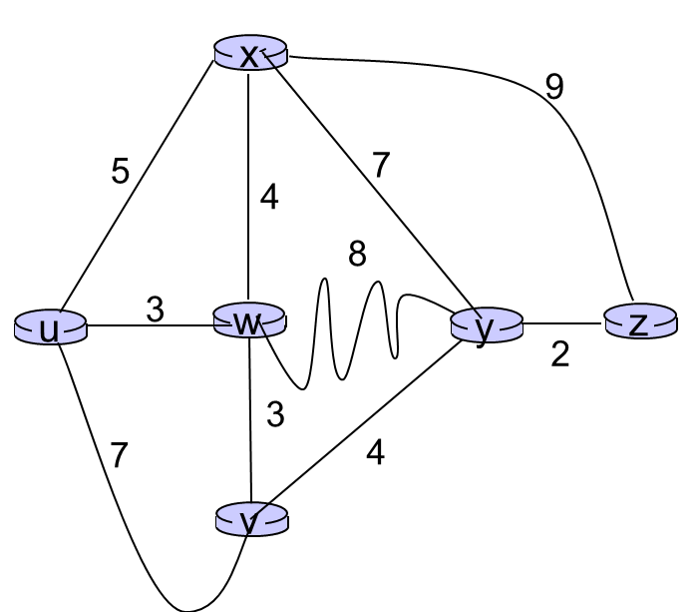

1. [10 marks] Show the operation of Dijkstra’s (Link State) algorithm for computing the least cost path from **u** to all destinations. From these results, state the least cost path from u to z, and briefly describe (in a sentence) how you got that answer from the results of the algorithm.

*Answer: See notes, we did this exact problem in the lectures. Shortest path is found by tracing predecessor nodes, also see exact solution in notes.*

1. [10 marks] Consider the three node network below. For this network use the distance vector algorithm to calculate the distance vectors at each node. You must demonstrate the algorithm working by showing the tables for each node after initialisation, and then after each iteration.

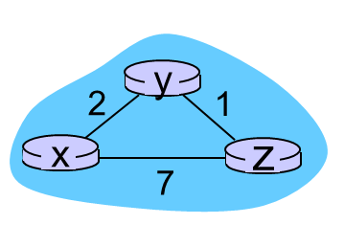

*Answer: See notes:*

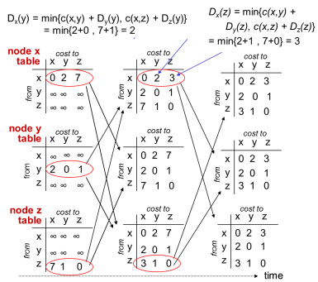

### Question 6. Link Layer [20 marks]

1. [4 marks] Suppose the information content of a packet is the bit pattern 1110 0110 1001 1101 and an even parity scheme is being used. What would the value of the field containing the parity bits be for the case of a two-dimensional parity scheme? Demonstrate using your answer that two-dimensional parity checks can correct and detect a single bit error.

*Answer*

*1 1 1 0 1*

*0 1 1 0 0*

*1 0 0 1 0*

*1 1 0 1 1*

*1 1 0 0 0*

*Demonstrating a single bit error is straightforward (see notes).*

1. [3 marks] Suppose four active nodes—nodes A, B, C and D—are competing for access to a channel using slotted ALOHA. Assume each node has an infinite number of packets to send. Each node attempts to transmit in each slot with probability *p*. What is the probability that node A succeeds for the first time in the second slot?

*Answer:*

*The probability that A is successful in any slot is given by*

*P(A) = p(1 – p)3*

*Remember how we derived this in the lectures?..... It is equal to the probability of A being successful (p), multiplying by the probability B is not successful (1-p) multiplying by the probability C is not successful (1-p) multiplying by the probability D is not successful (1-p)*

*Therefore the probability that A is successful in slot 2 for the first time is*

*=(probability A is not successful in slot1) x (probability A is successful in slot2)*

*=(1-P(A)) x P(A)*

*=(1 - p(1 – p)3)p(1 – p)3*

1. [3 marks] Consider a broadcast channel with *N* nodes and a transmission rate of *R* bps.Suppose the broadcast channel uses polling (with an additional polling node) for multiple access. Suppose the amount of time from when a node completes transmission until the subsequent node is permitted to transmit (that is, the polling delay) is *d*poll. Suppose that within a polling round, a given node is allowed to transmit at most *Q* bits. What is the maximum throughput of the broadcast channel?

*Answer:*

*The length of a polling round is*

*.*

*The number of bits transmitted in a polling round is . The maximum throughput therefore is*

**

**

1. Consider three LANs interconnected by two routers, as shown in the figure above
   * [2 marks] Assign IP addresses to all of the interfaces. For Subnet 1 use addresses of the form 192.168.1.xxx; for Subnet 2 uses addresses of the form 192.168.2.xxx; and for Subnet 3 use addresses of the form 192.168.3.xxx. Assign arbitrary MAC addresses to all of the adapters.

*Answer: you can assign ay numbers you want eg see figure below:*

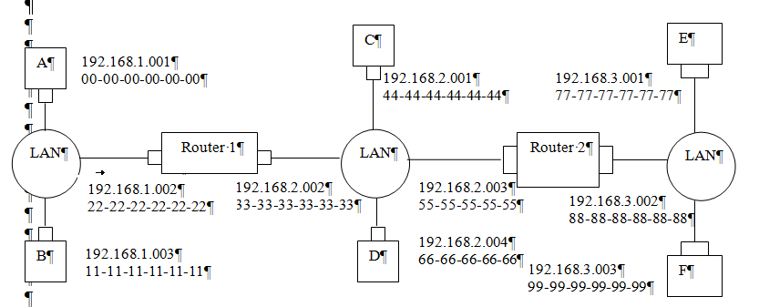

* + [5 marks] Consider sending an IP datagram from Host E to Host B. Suppose all of the ARP tables are up to date. List the steps that take place.

*Answer:*

* *Forwarding table in E determines that the datagram should be routed to interface 192.168.3.002.*
* *The adapter in E creates and Ethernet packet with Ethernet destination address 88-88-88-88-88-88.*
* *Router 2 receives the packet and extracts the datagram. The forwarding table in this router indicates that the datagram is to be routed to 198.162.2.002.*
* *Router 2 then sends the Ethernet packet with the destination address of 33-33-33-33-33-33 and source address of 55-55-55-55-55-55 via its interface with IP address of 198.162.2.003.*
* *The process continues until the packet has reached Host B.*
  + [3 marks] Repeat the previous question, now assuming that the ARP table in the sending host is empty (and the other tables are up to date).

*Answer: ARP in E must now determine the MAC address of 198.162.3.002. Host E sends out an ARP query packet within a broadcast Ethernet frame. Router 2 receives the query packet and sends to Host E an ARP response packet. This ARP response packet is carried by an Ethernet frame with Ethernet destination address 77-77-77-77-77-77.*